**Swordfish API – Developer Documentation**

Please find python installation and configuration documentation for windows and ubuntu Before jumping in to this documents

1. **Code Overview:**
   1. **Editing resource_manager.py file**:

* The redfish root structure is defined in Resourcemanager.py file .so now we have to make some suggested changes to run swordfish emulator.
* The resource manager file the structure consists of static and dynamic resources.
* The static resource snare loaded from default folders “.api_resources/redfish/static”, which is just a copy of mockups directory.

Below are the Screenshots for major changes.

A) Import all the Swordfish files 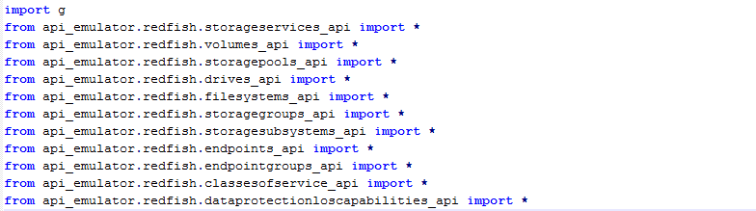

B) create Parent and child resources with uri’s

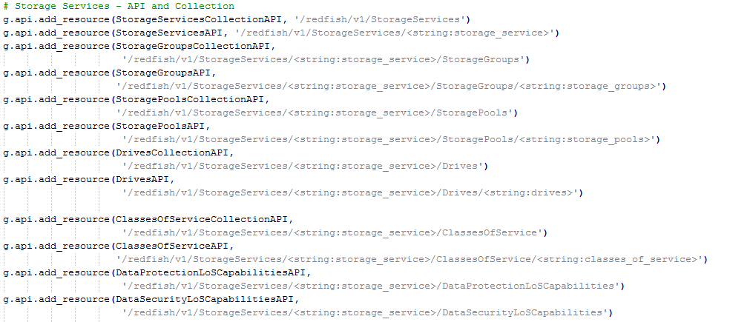

c) Configure New services StorageSystems and StorageServices

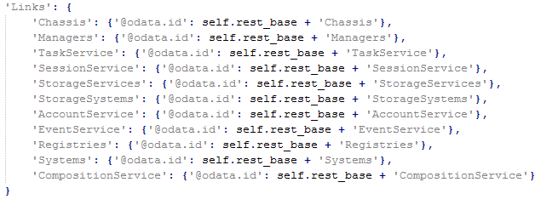

* 1. **Editing Utils.py file:**

We added new service for members count.

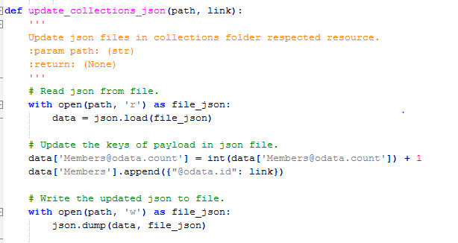

1. **Implementing Dynamic structure**

* The static resources are in /api_emulator/redfish/static/.. Folder, these are just a simple copy .
* The dynamic resource is in /Resource/.. Folder .We can specify any path to declare the dynamic resources.
* We have to create a template file and api files for dynamic structure.
* The file in template directory and api directory are to be paired appropriately.

1. **Writing l Template Files:**

* The template files are to unique files and singletons. For each and every new collection we have to create a template file. This template structure consists of a template declaration and function.
* The template structure is similar to json in mockups.
* Template file divides in to two types of sections. one is “template declaration” and other is “ function”
* Template declaration is as similar to json file (shown in below figure).
* Each template contains similar fields {rb}{id} which are declared in below function.

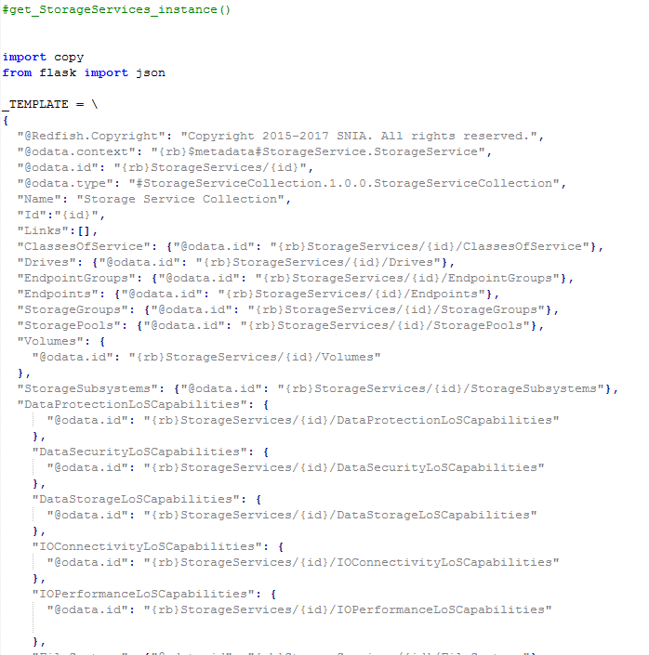

* Below figure contains function ,which is used to call the instance of resource.
* We are using wildcards for replacing the values .
* In the below we are using deep-ssscopy to make copy of template declaration.
* {rb} –{rest-base} is default set to {redfish/v1}

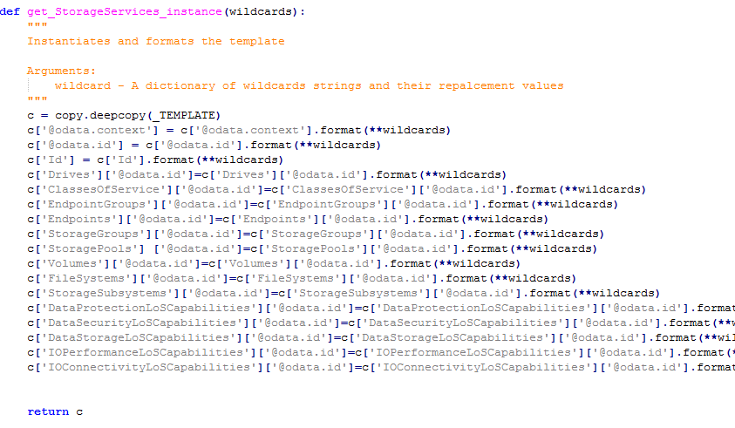

1. **Writing API Files:**

* The API files have HTTP functionality and which is interacting with all collections and member resources .
* For all API’S there are API classes and collection classes.
* All the http functions GET , POST, PATCH and DELETE are declared based on requirements.
* The Post function can create resources ,update members and members.id
* Post function can also attach API’s of sub resources and creates instance of sub-resources.

